Module 4: Critical Thinking Assignment

Nathan Rogers
Colorado State University Global
Course Code: CSC505
Dr. Luis Gonzalez
03/09/2025

Assignment
Using your personal experience and observation of people who are excellent software developers, use a UML diagram of your choice to depict three personality traits that appear to be common among them. Write a Python Script that will print a brief description and names and number of the important steps in your program.
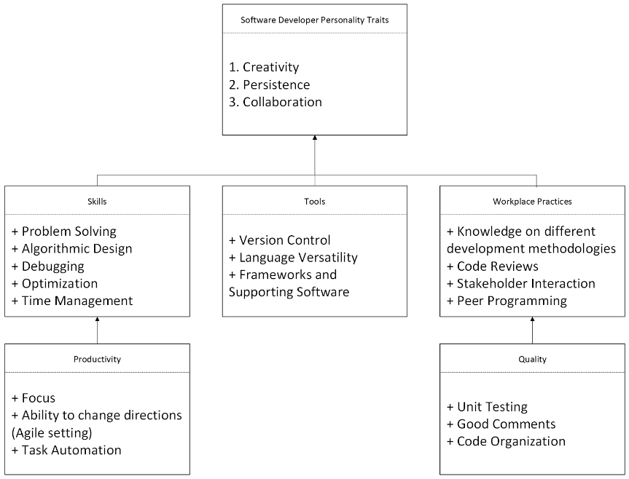
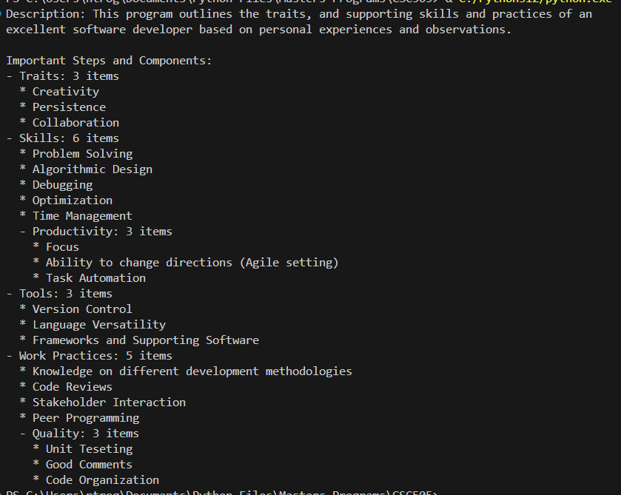

Personality Traits
Being a software engineer is much more than just sitting at a computer and writing code all day. A software engineer does have to write good, quality code but it involves having more tools and skills to draw from in areas of collaboration and determination. In my opinion, the three most important traits of a software engineer are Creativity, Persistence, Collaboration. Of course, there are many more good traits to have as a software engineer, but I believe many traits stem from these three.
Skills
Often times, when faced with a problem that can be solved with some form of software, the solution isn’t always straightforward or easy. Problem solving, debugging, algorithm design, optimization, and time management are all enhanced by creativity, persistence, and collaboration. Creativity fosters innovation and creative solutions to problem solving and algorithm design. Persistence is critical for finding and fixing issues using debugging tools and methodologies. I have personally been involved with finding the root cause of a memory leak within one of our iotedge docker microservices. Working with virtual machines such as docker images can be tricky on their own, however when you introduce complex issues such as memory leaks into the equation it multiplies the complexity ten-fold. This issue took me two weeks to track down and the outcome came down to a third-party package causing the memory leak rather than within our own code. Without patience, perseverance and persistence I wouldn’t have been able to find or fix the memory leak issue.
Mastering time management skills is another skill entirely. As a software engineer working on potentially several different issues and features, one must be able to efficiently and effectively manage one’s own time to meet all goals on time. Focus, task automation and the ability to change directions and work on several tasks at once all contribute to successful time management skills. In an Agile setting, which a lot of development teams utilize, software engineers are expected to constantly switch between developing different features depending on the current demands of stakeholders and the market. Every software engineer should strive to effectively stay on topic, be productive, and meet goals on time.
Tools
Versioning tools such as GitHub allow for all software engineers working on the same project to collaborate effectively and work with one another to solve problems in a meaningful way. GitHub should also be considered a skill by itself. Mastering this tool will enable you to help and contribute to the overall team, final goal, and help individuals solve specific problems within their own code.
A successful software engineer is also proficient in several languages and frameworks. Over the years, I have become proficient in 5 programming languages and several accompanying frameworks. This allows flexibility within the project to develop the necessary software tools and packages to complete the goal. One of the projects for Runtime Entertainment required us as developers to utilize 3 different operating systems, several scripts on top of the end-user mobile application, and two programming frameworks to meet the end goal. Due to the diversity that our team had, everyone was able to contribute and play into their own strengths towards each piece of the puzzle. Each person then got to learn something new in the process which also deepened the connection within the development team.
Workplace Practices
Collaborating and working with large groups of people can be tricky and tough. A successful software engineer must be able to communicate effectively not only to people within the development team but also to end users and stakeholders. Thinking back to the main traits, peer programming and code reviews, where two or more heads can be better than one, are heavily influenced by collaboration and creativity practices. Creativity can help a software navigate tricky issues that can arise with other developers but also adapt his own strengths and development practices to the overall team dynamic or project requirements.
Good and well written code and comments within blocks of code will not only help the software engineer who wrote it remember what it does several months down the line, but help other developers understand the code during code reviews and pull request reviews. Messy and unorganized code in production level software is unhelpful, difficult, and frustrating for developers to improve upon and add new features to existing code.
Interacting with stakeholders isn’t as easy as just reporting out what was accomplished. Not every stakeholder is as versed in development terminology and practices as the people developing the software are. A level of creativity and collaboration skills are required to explain in enough detail to bring the point across without bringing too much technical specific detail into the explanation. As a software engineer, you also need these skills to correctly interpret, understand, and translate requirements from stakeholders into goals, technical requirements and communications to the rest of the development team. It is also important to be persistent with stakeholders and negotiate what is possible within the software limitations and what is not, ensuring the software is well rounded and an end goal can be achieved.
References
Pressman, R. S., & Maxim, B. R. (2020). Software engineering: A practitioner’s approach. McGraw-Hill Education.
Zawadski, P. (2023, February 11). Top characteristics of a software engineer. WeAreDevelopers. https://www.wearedevelopers.com/en/magazine/166/characteristics-of-a-software-engineer-strengths-and-traits
Bruneaux, T. (2024, May 20). Why team collaboration is vital in software development. DX. https://getdx.com/blog/software-collaboration/

